Chapter 5. Building and Applying Logistic Regression Models

5.1 Strategy in model selection
5.1.1 How many explanatory variables can the model handle?
The dataset should contain at least 10 outcomes of each type for every explanatory variable. For example, if $y=1$ only 30 times out of $n=1000$ observations, the model should have no more than $p=3$ explanatory variables even though the overall sample size is quite large. When this guideline is violated badly, ML estimators of effects and standard errors may be highly biased.

5.1.2 Example: Horseshoe Crab Satellites
In Horseshoe Crab dataset, the data file has four explanatory variables: (1) color (four categories), (2) spine condition (three categories), (3) shell width, and (4) weight. If we use all of them in logistic regression model, the model is
$$logit\left[P\left(Y=1\right)\right]=α+β_{1} weight+β_{2} width+β_{3}c_{2}+β_{4}c_{3}+β_{5}c_{4}+β_{6}s_{2}+β_{7}s_{3}.$$
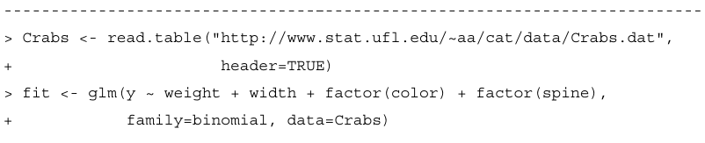
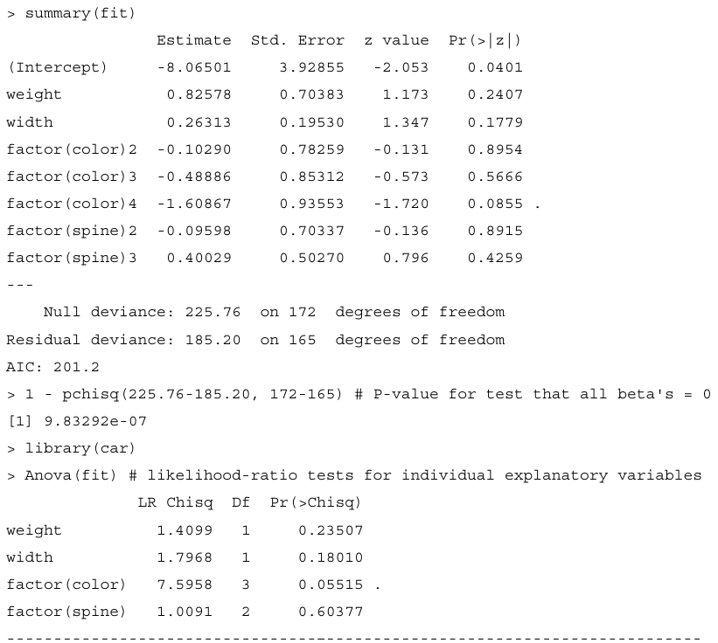
To test $H_{0}: β_{1}=…=β_{7}=0$, the test statistic is $225.76-185.20=40.56$ with $df=172-165=7$, which shows strong evidence that at least one explanatory variable has an effect.
However, the likelihood-ratio tests for individual explanatory variables show nothing significant at the 0.05 level. The p-value for the overall test is small, while the lack of significance for individual effects is a warning sign of multicollinearity.

5.1.3 Variable selection algorithms
Backward elimination begins with a complex model and sequentially removes terms. It eliminates the term that has the largest p-value in the model, and the process stops when any further deletion leads to a significantly poorer fit.
Forward selection starts with the null model and add terms sequentially until further additions do not improve the fit.
For categorical explanatory variables with more than two categories, the process should consider the entire variable at any stage rather than just individual variables. It should add or drop the entire variable rather than just one of its indicators.
Also, it’s inappropriate in backward elimination to remove a main effect if the model contains higher-order interactions involving that term. It is not sensible to use a model with interaction but not the main effects that make up that interaction. Otherwise, the statistical significance and practical interpretation of a higher-order term depends on how the variables are coded.
Variable selection methods don’t need to yield a meaningful model. You should regard its results with skepticism. When you evaluate many terms, one or two that are not truly important may look impressive merely due to chance. In any case, true statistical significance is not simple to judge for effects highlighted as being the most or the least significant, and it should not be the sole criterion for whether to include a term in a model. It is sensible to include a variable that is important for the purposes of the study and report its estimated effect even if it is not statistically significant. If the variable is a potential confounder, including it in the model may help to reduce bias in estimating relevant effects of key explanatory variables and may make it possible to compare results with other studies where the effect is significant, perhaps because of a larger sample size. On the other hand, with a very large $n$, sometimes a term might be statistically significant but not practically significant.

5.1.4 Purposeful selection of explanatory variables
A purposeful selection process proposed by Hosmer et al. (2013, Chapter 4) uses several steps to build a model.
1. Construct an initial main-effects model using explanatory variables that include the known important variables and others that show any evidence of being relevant when used as sole predictors (e.g., having P-value < 0.2).
2. Conduct backward elimination, keeping a variable if it is either significant at a somewhat more stringent level or shows evidence of being a relevant confounder, in the sense that the estimated effect of a key variable changes substantially when it is removed.
3. Add to the model any variables that were not included in step 1 but that are significant when adjusting for the variables in the model after step 2, since a variable may not be significantly associated with y but may make an important contribution in the presence of other variables.
4. Check for plausible interactions among variables in the model after step 3, using significance tests at conventional levels such as 0.05.
5. Conduct follow-up diagnostic investigations presented in Section5.2.

5.1.5 Example: Variable selection for Horseshoe crab
In Table 5.1, we compare several logistic regression models with crab width $(W)$, color $(C)$, and spine condition $(S)$ as explanatory variables, regarding $C$ and $S$ as factors.

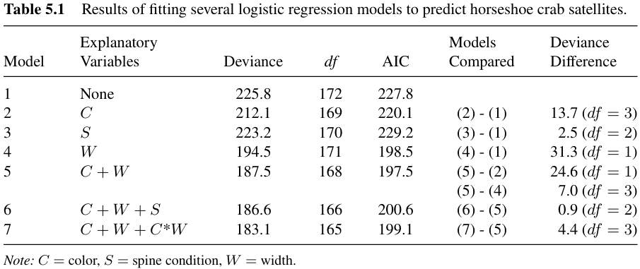
At step 1, we compare the null model (model 1) to model 2, 3, 4. These show that color and width are statistically significant. Therefore, after step 1, the purposeful selection process includes color and width as initial explanatory variables, which is model 5.
At step 2, backward elimination compares model 5 to model 2 and 4. A large increase in deviance $(24.6, df=1, p-value<0.01)$ results from removing $W$, and a moderate increase $(7.0, df=3, p-value=0.07)$ results from removing $C$, so we leave them both.
At step 3, we compare model 5 and model 6. The decrease in deviance $(0.9, df=2)$ is not significant, so we keep $W$ and $C$ as the only predictors.
At step 4, model 7 adds the interaction between $W$ and $C$ by adding three cross-product terms between $W$ and the indicator variables for $C$. The decrease in deviance $(4.4, df=3, p-value=0.22)$ is not significantly better.
Thus, the final model has solely color and width explanatory variables as main effects.

5.1.6 AIC and the bias/variance tradeoff
In selecting a model through some model-building process, you should not conclude that you have found the “correct” one. Any model is a simplification of reality.
In selecting a model for any statistical analysis, a fundamental tradeoff occurs between bias and variance. Consider two models, one of which is simpler than the other. The simpler model has more potential bias, such as a true probability differing more greatly from the value corresponding to fitting the model to the population. However, the simpler model has the advantage that its smaller number of parameters results in a smaller variance for estimating characteristics of interest. Therefore, it is not necessarily better to select the more complex model, even though it has a smaller deviance and perhaps fits better in terms of statistical significance.
Some criteria besides significance tests can help select a good model. Akaike information criterion (AIC) judges a model by how close its fitted values tend to be to the true expected values. The optimal model, which tends to have its fitted values closest to the true outcome probabilities, is the one that minimizes
$$AIC=-2\left(log likelihood\right)+2\left(number of parameters in model\right).$$
Because smaller AIC is better, the AIC penalizes a model for having many parameters.
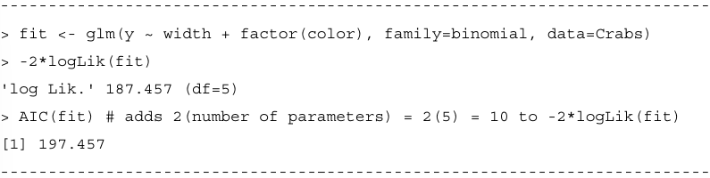
For example, the model of $C+W$ in Table 5.1 has 5 parameters, so $AIC=187.46+2\left(5\right)=197.46$. Of models using some or all of the three basic explanatory variables, AIC is smallest for that model.
AIC can also be the basis of stepwise model selection. For instance, the next R output uses AIC to select a model in a backward manner. We start with all four potential explanatory variables as main effects. At each step we remove the variable so that AIC decreases the most, until we get to the stage in which AIC increases if we remove any other variables:
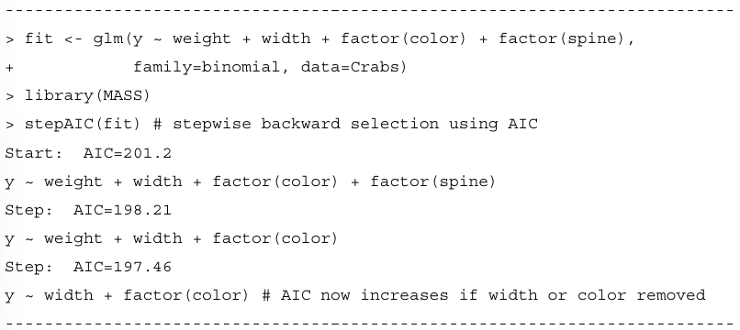
Alternatively, we can search for the subset that has the smallest AIC when used as explanatory variables in a logistic model. This results in the same model. Here, we show this approach with color and spine condition treated as quantitative:
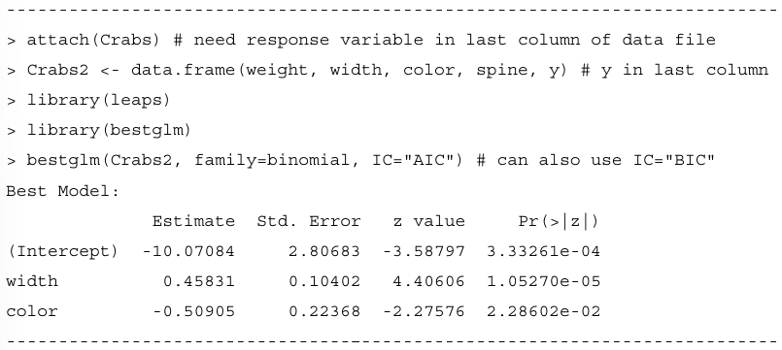
Alternatively, we can use model averaging to combine results from several models that seem similar in quality according to an index such as AIC. This is beyond our scope. See Burnham and Anderson (2003) for details about AIC and related indices and model averaging. They recommend using a bias-corrected version AICc when the number of parameters is relatively large. An alternative criterion, called BIC, replaces 2 by log(n) in the penalty multiple of the number of parameters. Designed to select the “correct” model as n gets very large, this index penalizes more strongly for having many parameters. Minimizing it can yield a more parsimonious model. When n is quite large, this is useful, because models can then more easily have effects that are statistically significant but not practically significant. For the horseshoe crab data, all these criteria select the same model.

